**Sequence Diagram:**

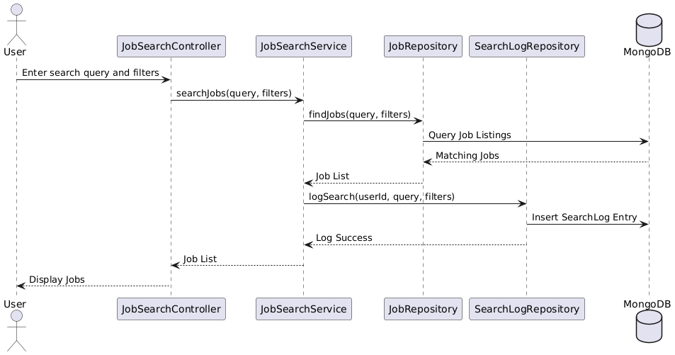

**Class Diagram:**

**State Diagram:**

**ERD:**

**Functional Requirements**

1. The system must allow users to enter keywords and filters to search for jobs.

|  |
| --- |
| 1. The system must fetch job listings based on keywords, category, location, or skills. |

|  |  |
| --- | --- |
|  | 1. The system must display a list of matching job results. |

|  |  |
| --- | --- |
|  | 1. The system must allow users to view detailed job information. |

|  |  |
| --- | --- |
|  | 1. The system must log user search actions for analytics. |

**Non-functional Requirements**

|  |
| --- |
| 1. The search results should load in less than 2 seconds. |

|  |  |
| --- | --- |
|  | 1. The system should support fuzzy matching and keyword relevance. |

|  |  |
| --- | --- |
|  | 1. The job listings must be paginated for better performance. |

|  |  |
| --- | --- |
|  | 1. The system should support concurrent searches from thousands of users. |

|  |  |
| --- | --- |
|  | 1. Search logs should be stored securely and used for personalized suggestions. |